**Daily Scrum or Standup Meeting**

Team name: Group 8_________________________

Scrum Master: Cole_______________________

Date: 3-22-2021_______________________________

|  |  |  |  |
| --- | --- | --- | --- |
| **Team Member** | **What did you do since the last scrum?** | **What do you plan to do before the next scrum?** | **What obstacles do you have?** |
| Cole | Worked on designs for lot admin and spot validation | Recharge my batteries a little | Time |
| Logan | Got started on the Django REST framework tutorial | Work on authentication and login API | Time |
| Austin | Met with Cole and Jeremy and divided up work, working on customer views in React | Get started integrating the APIs into React | None |
| Jeremy | Met with Austin, got some guidance on which APIs are needed | Continue working on APIs | None |
|  |  |  |  |

# Burndown

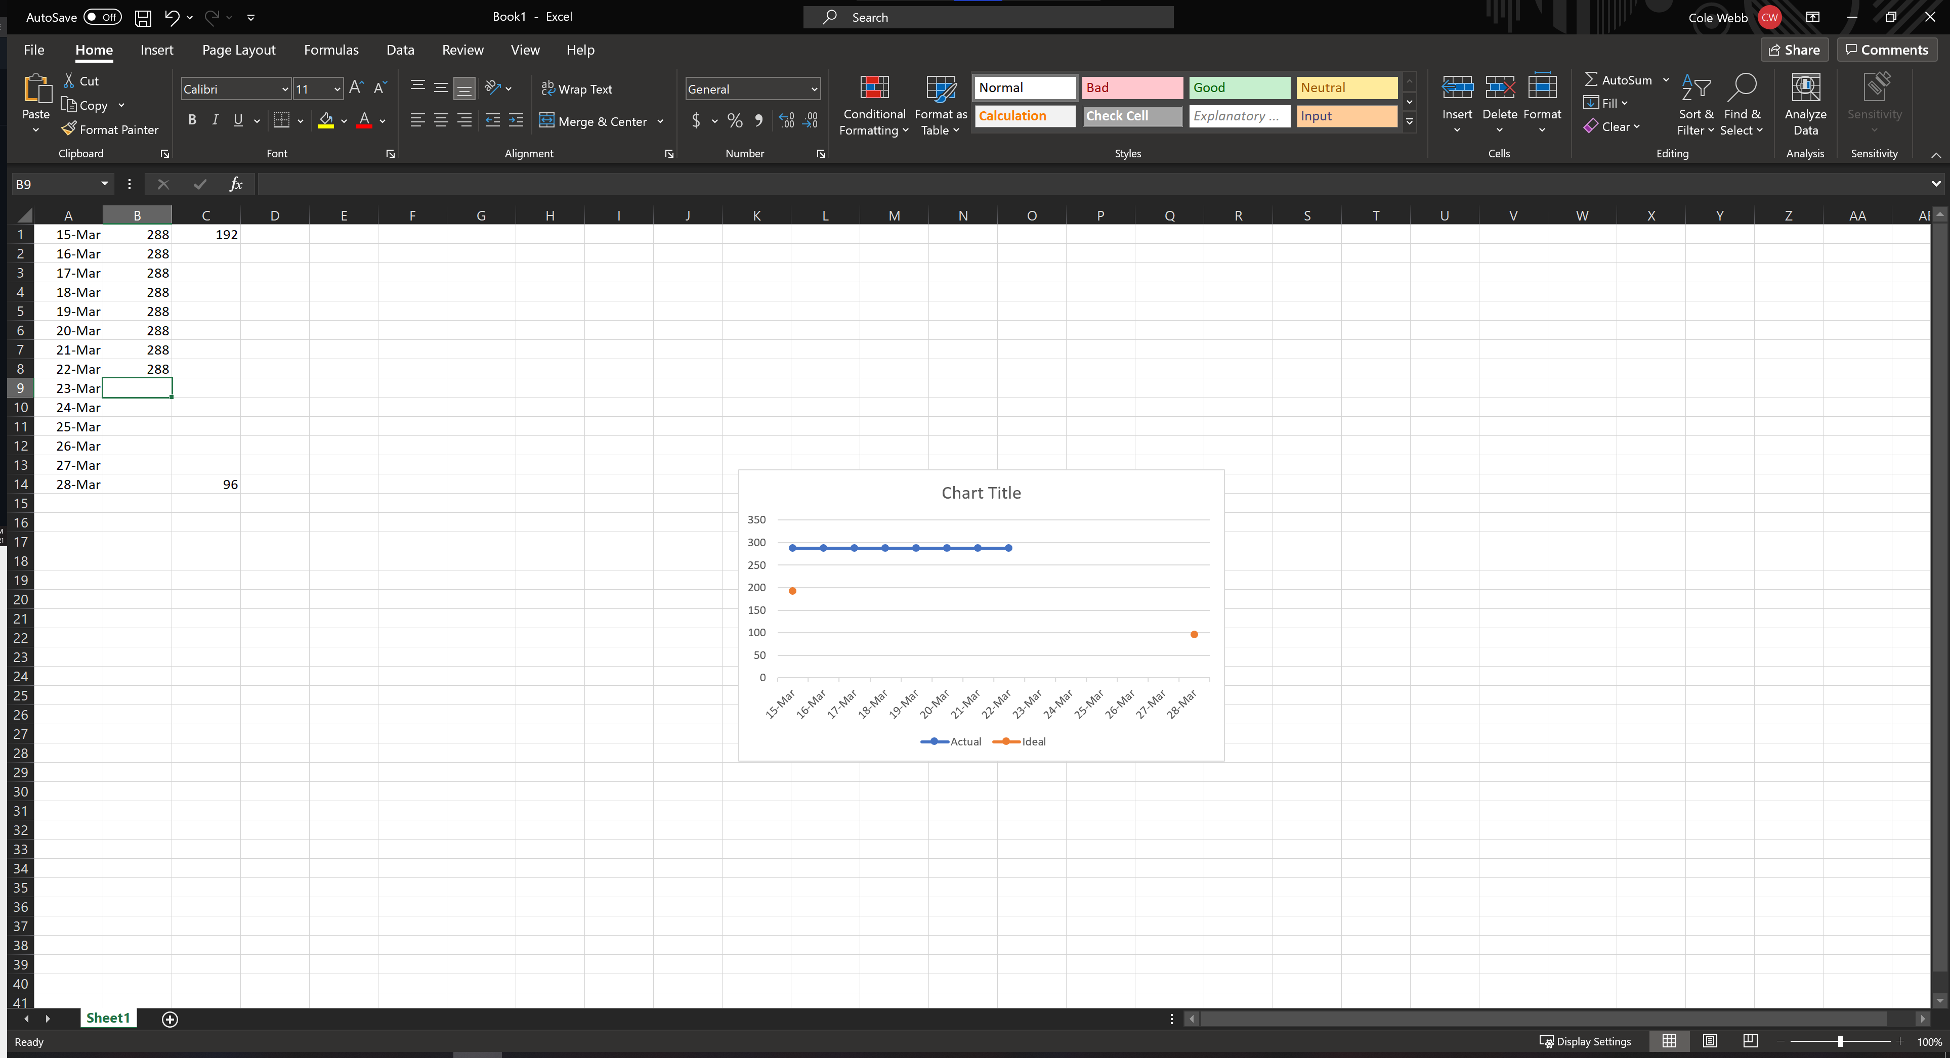

# Screenshot of you project board

